POWER BI ASSIGNMENT 2
DAX & DATA VISUALIZATION
E-Commerce Sales Analysis
Prepared by: Mathilakath Sharan

1. Data Import
Imported the three required CSV files into Power BI: List of Orders, Order Details, and Sales Target. The data was checked to ensure the required fields were available for analysis.
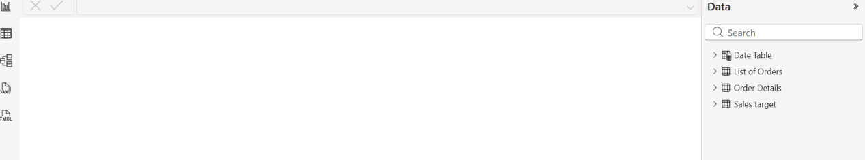

2. Data Modeling
Created the required relationships between the order and order-detail data. A Date Table was created and connected to Order Date. Category and sales-target data were also linked so that actual sales and targets could be analysed together.
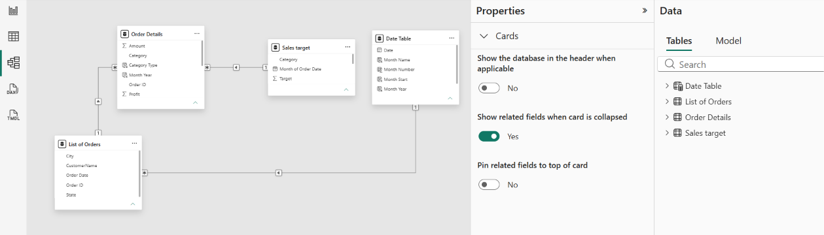

3. Calculated Columns
Created the required calculated columns in Order Details: Category Type, Revenue per Order, and Sales Category. These columns were used to classify and analyse individual order records.
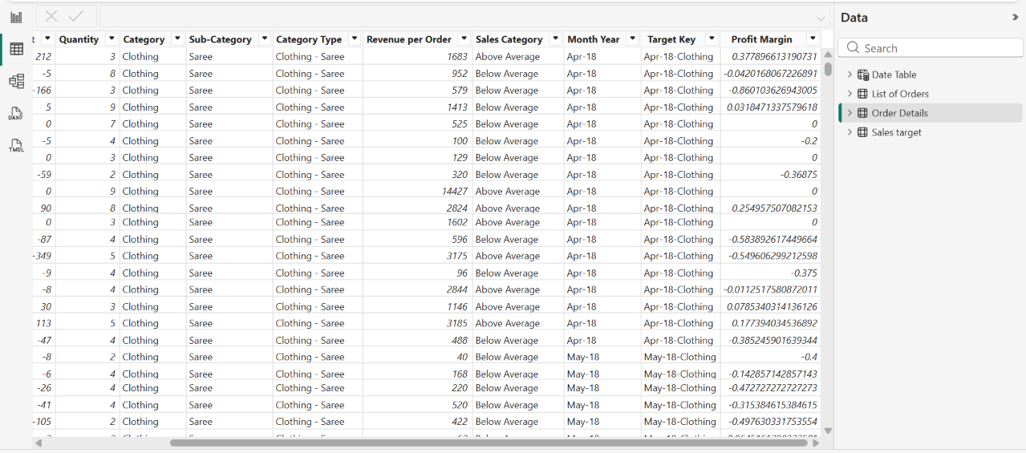

4. Calculated Measures
Created the required measures for Order Count, Average Profit in Delhi, and Year-to-Date Sales. Supporting measures such as Total Sales, Sales Target, Total Profit, Total Quantity, and Profit Margin were also created for the visualizations.
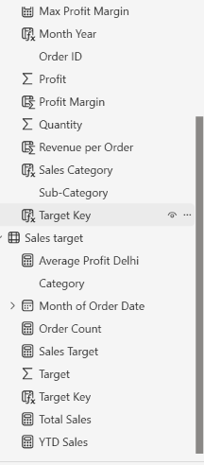

5. Date Table
Created a Date Table covering the order-date range. Added Year, Month, Month Number, and Month Year fields. Month fields were sorted chronologically so that the monthly sales trend displays in the correct order.
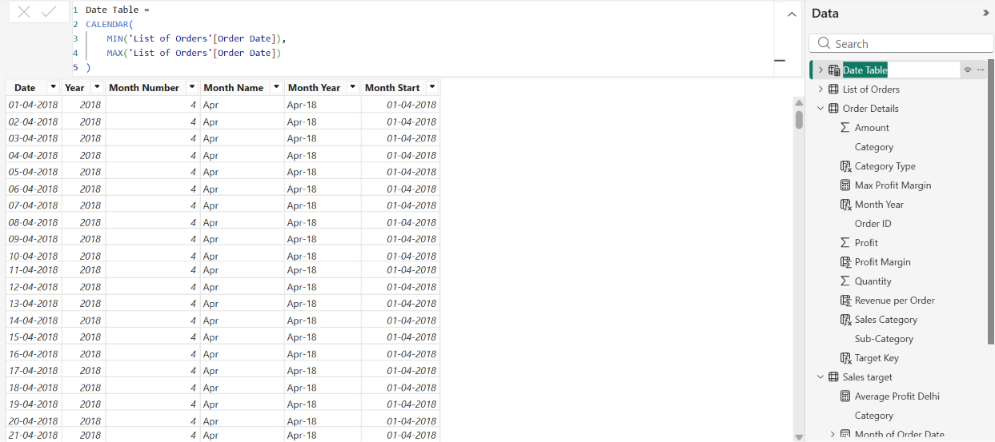

6. Data Visualization
Created the required Power BI visuals: Sales Target Achievement by Category, Max Profit Margin by Sub-Category, Monthly Sales Trend, Profit and Quantity by Sub-Category, Total Sales and Target cards, Minimum Target by Category, Sales Performance Matrix, Geographic Sales Analysis by City, Sales Distribution by Sub-Category, and Order Count Analysis by State.

7. Dashboard Formatting
Added a clear dashboard heading and formatted the visuals for readability. Visuals were arranged neatly, titles were provided, and the layout was adjusted to make comparisons and trends easy to understand.

8. Final Outcome
The completed dashboard provides an interactive overview of e-commerce sales performance, including actual sales, targets, profitability, quantity, monthly trends, sub-category performance, and geographic distribution.
